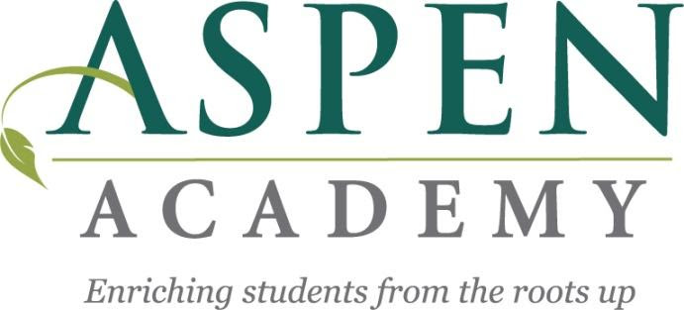
3-12-2025

Dear Aspen Academy Staff and Parents:

Aspen Academy’s annual Board election will conclude on May 11th, 2025. The Aspen community will be voting for 2 parent Board members, 1 teacher and 2 community Board members. The parent member terms are 3 years and community member terms are two years. All newly elected Board members start on July 1, 2025.

Community Board members must meet the following qualifications at the time of application: must be a resident of MN, a minimum of 21 years of age, and must not have been employed by or have had a student enrolled at Aspen Academy in the last nine months. See Aspen Academy Bylaws for more information.

Parent Board members must meet the following qualifications at the time of application: must be a minimum of 21 years of age and be a parent/guardian of a child enrolled at Aspen and who are not employees of the school. See the Aspen Academy Bylaws for more information.

The role of the Board of Directors is the support and oversight of the school, setting policy, and participating in long range strategic planning. New and existing Board members will be supported through school sponsored trainings as well as informal connections with administrators and fellow Board members. Please share this with community members (non-Aspen parents and staff) that may be interested in supporting our school.

More information about the Aspen Academy Board of Directors can be found at www.aspenacademymn.org/parents/board/ and in the general board information presentation link below. If you have any questions about Board service or would like to receive more information, please contact Board Secretary Stephanie Smitley at stephanie.smitley@aspenacademymn.org. Applications and conflict of interest forms for the election should be submitted by March 28th, 2025 via email to Stephanie Smitley at the email address above. Prospective candidates are asked to please attend the March, April, May and June Board meetings as well as any committee meetings.

Sincerely,

Board Elections, Responsibilities and Governance Committee
On behalf of the Aspen Academy Board of Directors

